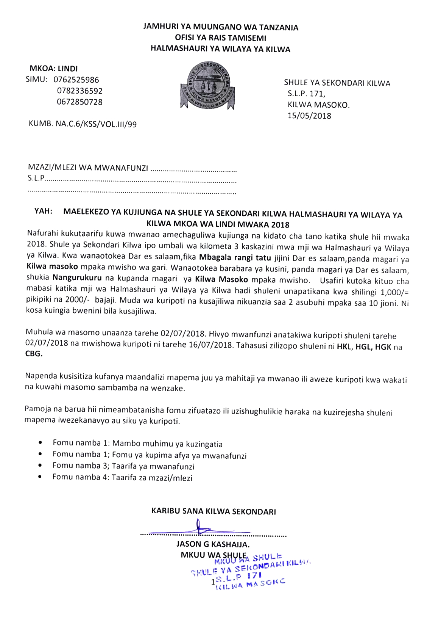 JAMHURI YA MUUNGANO WA TANZANIA
OFISI YA RAIS TAMISEMI
HALMASHAURI YA WILAYA YA KILWA

MKOA: LINDI
SIMU: 0762525986 SHULE YA SEKONDARI YA KILWA
0782336592 S.L.P. 171,
0672850728 KILWA MASOKO.
15/05/2018
KUMB. NA.C.6/KSS/VOL.III/99

FOMU NAMBA 1.
- MAMBO MUHIMU YA KUZINGATIA
1:1 Sare ya shule
- Sare ya shule ni suruali ya blue nyeusi(dark blue) jozi 2, mkanda mweusi, mashati meupe mikono mifupi jozi 2. Viatu vyeusi vya ngozi (sio buti) na socksi nyeupe jozi mbili.
- Aje na sare ya michezo; raba nyeupe,bukta/tracksuit ya bluu na t-shirt ya bluu (chelsea).
- Anaweza kuja na sweta la bluu ili kujikinga na msimu wa baridi.
- Aje na nguo za kushindia (shamba dress) suruali nyeusi jozi moja, T-shirt rangi ya kijivu na yenye kola.
1:2 Ada ya shule (Ilipwe Benki).
- Ada ya shule kwa mwaka ni shilingi 70,000/= inaweza kulipwa 35,000/= kwa muhula.
Fedha hizo zilipwe kwenye Akaunti ya shule Na 70110000222 KILWA SECONDARY SCHOOL RECURRENT A/C katika Benki ya NMB na bank pay in slip iwasilishwe shuleni ili apatiwe risiti.
- Michango inayotakiwa kulipwa na kila mzazi (Ilipwe Benki) ni:-
- Shilingi 15,000/= kwa ajili ya ukarabati
- Shilingi 6,000/= kwa ajili ya kitambulisho
- Shilingi 20,000/= kwa ajili ya taaluma
- Shilingi 30,000/= wapishi,walinzi na vibarua wengine
- Shilingi 2,000/= nembo ya shule
- Shilingi 10,000/=matibabu ya huduma ya kwanza. Wanafunzi wasiokuwa na Bima ya Afya wataunganishwa katika mfuko wa bima ya afya CHF kikaya.
- Shilingi 20,000/= mitihani ya kujipima (mock) kidato cha sita.
- shilingi 5,000/= tahadhari (haitarejeshwa)
NB:Jumla ya Michango yote ya kipengele 1:2(a na b) ni Tsh.178,000/= na ilipwe kwenye akaunti ya shule NMB Na 70110000222 KILWA SECONDARY SCHOOL RECURRENT A/C
- Mahitaji muhimu ambayo mwanafunzi anapaswa kuleta shuleni ni: -
- Ream 1 ya karatasi (A4)
- Vitabu vya masomo ya tahasusi husika (HKL, HGL, HGK na CBG), Scientific Calculator na Dissecting kit kwa somo la biolobia.
NB Orodha ya vitabu kwa tahasusi zote imeambatanishwa kwenye ukurasa wa mwisho.

- Godoro la kulalia futri mbili na nusu kwa sita(2 1/2x 6)
- Mashuka 2 ya bluu , mto 1, foronya 1 (rangi bluu)
- Vyombo vya kulia chakula aje na sahani 1, bakuli 1, kikombe 1, jagi 1, kijiko.
- Picha 4 za passipoti
- Ndoo1 kubwa na 2 ndogo kwa ajili ya matumizi binafsi.
- Kwanja 1, jembe1 lenye mpini, fagio ya ndani 1 na fagio ya nje 1
- Kandambili, mswaki na taulo
(x)Sabuni ya maji lita 1.
(xi)Nakala ya cheti cha kuzaliwa pamoja result slip ya mtihani wa kidato cha nne mwaka 2017

NB: NGUO AMBAZO HAZIKUAGIZWA HUMU HAZIRUHUSIWI!

- MAKOSA YATAKAYO SABABISHA MWANAFUNZI KUFUKUZWA SHULE
- Wizi
- Kutohudhiria masomo kwa zaidi ya siku 60 bila taarifa/ utoro
- Kugoma na kuhamasisha mgomo
- Kutoa lugha chafu kwa wanafunzi wenzake, walimu/walezi na jamii kwa ujumla
- Kupigana mwanafunzi kwa mwanafunzi au kumpiga mwalimu au na mtu yeyote yule.
- Ulevi au unywaji wa pombe na matumizi ya madawa ya kulevya
- Uvutaji wa sigara
- Uasherati, uhusiano wa jinsi moja, kuoa au kuolewa
- Kusababisha ujauzito au kutoa mimba
- Kutembelea majumba ya starehe na nyumba za kulala wageni
- Kumiliki simu ya mkononi shuleni
- Kudharau Bendera ya Taifa
- Kufanya jaribio lolote la kujiua au kutishia kujiua kama kunywa sumu n.k
- Uharibifu wa mali ya umma kwa makusudi.

- Mambo mengine muhimu
- Medical Examination form ambayo itajazwa na Mganga Mkuu wa Hospitali ya Serikali .
- Fomu ya maelezo binafsi kuhusu hisitoria ya mwanafunzi/mkataba wa kutoshiriki katika mgomo fujo na makosa ya jinai.
- Fomu ya mzazi kukiri kukubaliana na sheria na kanuni, kulipa ada na michango na maelekezo mengine yatakayotolewa na shule.

- Tafadhali soma kwa makini maelezo/maagizo haya nakuyatekeleza kikamilifu

THE UNITED REPUBLIC OF TANZANIA
PRESIDENTS OFFICE, REGIONAL ADMINISTRATIVE AND LOCAL GOVERNMENT
KILWA DISTRICT COUNCIL
REGION: LINDI
PHONE: 0762525986 KILWA SECONDARY SCHOOL
0672850728 P.O.BOX 171,
0782336592 KILWA MASOKO.
15/05/2018
KUMB. NA.C.6/KSS/VOL.III/99

FORM 2:
To the medical officer
..

RE: REQUEST FOR MEDICAL EXAMINATION OF MR/MISS
Please examine the above named pupil and give us the report regarding his/her suitability for undertaking secondary school education as a student on the following grounds:
- Pupil full name . Age
- Blood
- Stool ......
- T.B. Test
- Syphilis .
- Urine examination .
- Eye test .
- Chest test .
- Ears test .
- Spleen
- Abdomen .
- Pregnancy test (for girls only) .
ANY ADDITIONAL INFORMATION E.g. physical defects or impairment, infection, family diseases, etc

I certify that, the above named pupil is suitable/unsuitable for secondary school studies. If unsuitable give reason(s)

NAME OF MEDICAL OFFICER . SIGNATURE AND STAMP

JAMHURI YA MUUNGANO WA TANZANIA
OFISI YA RAIS TAMISEMI
HALMASHAURI YA WILAYA YA KILWA

MKOA: LINDI
SIMU: 0762525986 SHULE YA SEKONDARI YA KILWA
0782336592 S.L.P. 171,
0672850728 KILWA MASOKO.
15/05/2018
KUMB. NA.C.6/KSS/VOL.III/99

FOMU NAMBA 3.
TAARIFA ZA MWANFUNZI
- (a) Jina la mwanafunzi
(b) Jinsia .
(c) Anuani .

- Tarehe ya kuzaliwa . mwezi . mwaka .
- Shule aliyomalizia kidato cha nne mwaka .
- Mkoa anaotoka . wilaya alipozaliwa .
- Tarafa anayotoka . kata atokayo ...
- Kijiji anachotoka . mtaa anaotoka .
- Jina la mtendaji wa (a) Kata . (b) Mtaa/kijiji .
- Jina la (a) Balozi wa nyumba kumi .
(b) Mwenyekiti wa mtaa

- Michezo anayopendelea
Na. | Jina la mchezo
1
2
3
4
5

- Nafasi yoyote ya uongozi aliyowahi kushika
Na. | Aina ya uongozi | Shule | Mwaka

Nathibitisha kwamba taarifa nilizozitoa hapo juu ni za kweli, pia nathibitisha kuwa nitakuwa na tabia nzuri, mchapa kazi pamoja na kuwa na bidii ya masomo

Jina la Mwanafunzi .Sahihi Tarehe ...

JAMHURI YA MUUNGANO WA TANZANIA
OFISI YA RAIS TAMISEMI
HALMASHAURI YA WILAYA YA KILWA
MKOA: LINDI
SIMU: 0762525986 SHULE YA SEKONDARI YA KILWA
0782336592 S.L.P. 171,
0672850728 KILWA MASOKO.
15/05/2018
KUMB. NA.C.6/KSS/VOL.III/99

FOMU NAMBA 3.
TAARIFA ZA MZAZI/MLEZI

- Jina kamili la mzazi/mlezi
- Kazi afanyayo .
- Anuani .namba ya simu ..
- Mkoa . wilaya .tarafa ..
- Kata kijiji mtaa
- Anuani kamili ya nyumbani ambako mtoto atakuwa anakwenda wakati walikizo
Mahali ... kwa nani . simu
- Majina ya viongozi/ wazazi wake
Jina la baba mtendaji wa kijiji/mtaa .
Mtendaji wa kata ..
Mwenyekiti wa mtaa .
Balozi wako wa nyumba kumi ...

- Wazazi walio hai
- Idadi ya ndugu wa kiume idadi ya ndugu wa kike .
- Wewe wa ngapi kuzaliwa ? ..

Mimi mzazi/mlezi wa . nina ahidi kushirikiana na walimu pamoja na watumishi wote wa shule ya Sekondari Kilwa katika kumlea mwanangu kwa muda wote atakapokuwa shuleni ikiwa pamoja na kumlipia ada ya shule na mahitaji mengine.

Nitaomba kujulishwa mara moja endapo mwanangu ameenda kinyume na sheria, kanuni na taratibu za shule. Pia nitakuwa tayari mwanangu kupewa adhabu inayostahili kwa makossa atakayofanya.

Jina la mzazi/mlezi Sahihi . Tarehe

ORODHA YA VITABU

GENERAL STUDIES
1.General studies for Advanced level certificate,Form six(6)by Richard R.F.Mbalase(2011)
2. General studies for Advanced level certificate,Form five(5)by Richard R.F.Mbalase(2011)
3.Contemporary approach for Advanced level  General studies NotesForm 5&6 by Nyambari C.M
Nyangwine,Godfrey Rutta Nyangwine,Steven O. Maluka(New syllabus(2009)

KISWAHILI
1.Kimbunga H.Gora(taasisi ya uchunguzi wa Kiswahili)(tuki),1994
2.Mapenzi Bora S.Robert (mkuki na nyota)
3.Chungu Tamu-T.A MVUNGI (Tanzania Publishing house ),1985
4.Fungate ya uhuru M.S Khatibu (macmillan and aidan)
5.Vuta Nkuvute Shafi(mkuki na nyota 1999)
6.Kufikirika-S.Robert (mkuki na nyota 2003)
7.Mfadhili Hussein Tawa (Methew &stationery 2007)
8.Usiku utakapokwisha-Mbunda Msokile 2007
9.Morani-E.Mbogo
10.Nguzo mama-P.Muhando
11.Kivuli kinaishi-
12.Kwenye ukingo wa Thim-E.Hussein
13.Kunga za fasihi na lugha M.Msokile(1992)
14.Fasihi-F.E.M.K.Senkolo 1984
15.Kitangulizi cha tafsiri nadharia na mbinu-Mwansoko ,H.J.M. (1996)
16.Nadharia ya lugha kidato cha tano na sita Suluhaya ,M.C.(2010) silabsi mpya.
17.Nadharia ya fasihi(kipya) J.A masebo chapa ya tisa.-silabasi mpya.

GEOGRAPHY
1.Principles of physical geography by Monkhouse(2008)
2.Landforms in Africa by collinBuckle
3.Statistics simplified by N.A.Saleem
4.Map reading by Mac Master
5.Human and Economic Geography by C.Morgan (1982)
6.Map reading ,General publications Ltd dsm by Durra,S.E.(2003)
7.Geography An intergrated Apprpoach ;Fourth edition by David Waugh(2009)
8.Practical Geography for AFRICA by John .M.Pritchard(1990)
9.R.B.Bunnet (2007)General Geography in diagrams

HISTORY
1.Major issues in African history by Tanzania institute of education
2.History of modern Europe by peacock
3.How Europe underdeveloped Africa by w. Rodney
4.History in focus ;modern world history by Ben Walsh
5.Matering advanced level history book two,by Kato,A(2011)
6. Matering advanced level history book one,by Kato,A(2012)

ENGLISH
1.Macmillan Education Ltd 2000,Encounters from Africa ,Macmillan
2.Ayi Kwei Amah,1996,The beautiful ones are not yet born,EAEP
3.Chinua Achebe ,1991,a man of the people,BAEP
4.Ndunguru 1999 ,Divine Providence,mkuki na nyota
5.Magala Nyago,1985,The Rape of the Pearl Macmillan
6.Namige Kayondo,1995 Vanishing shadows, Macmillan
7.Danny Sato,1983,His Excellency the head of state, Macmillan
8.David Omowale,2002,A season of welting ,EAEP
9.Francis Lubuga ,1990,Betrayer in the city,Heinemann
10.Ngugi wa Thiongo,et al 1982,I will marry when I want,EAEP
11.Bukenya,1984,The Bride, EAEP
12.Okot Omitah 1991,Lwanda Magere Heinemann
13.Henrick Ibsen ,1974,An Enemy of the people,Eyre Matheuen
14.John Ruganda 2005,Black Mamba, EAEP
15.Charles Mloka,2002,The wonderful surgeon and other poems,mkuki na nyota
16.Tanzania Institute of Education ,1996,selected poems,Print pak(t)Limited.
17.The real English textbook for Advanced level ,Dr, Kadeghe Michael
NB: Oxford Advanced Learners Dictionary 6th or 7th Edition

CHEMISTRY
1.Advanced chemistry physical and industrial by P.Mathew(2006)
2.Essentials of physical chemistry by Arun Bahil,B.S Bahil &G.D Tuli (2012)
3.Organic Part A&B by A.Abdullah &M.H Nkunya
4.Inorganic Part A&B by J.S.Maro Guerman&M.Mikesewala(1989)
5.Physical chemistry by Ddungu&J.B.A.Mihigo(1998)
6.Advanced level Inorganic chemistry Part I&II by Tanzania Institute of Education(1995)
7.Organic chemistry an introduction by Jack E.Fernandez(1982)
8.Uderstsnding chemistry for A-Level students
9.Conceptual chemistry for class XII&XI by S.K Jaini (2011)
10.Advanced level chemistry,fourth edition by Ramsden(2000)
BIOLOGY
1.Dissecting kit
2.New understsnding Biology for A-level student by Glenn&S.Toole(1999)
3.Systematic and classification by L.K Msaki(1993)
4.Biology,A functional Approach b M.B.V Roberts(1971)
5.Advanced Biology :Principle and application by C.J.Clegg&D.G.Mackean(2000)
6.Biological Science by Taylor ,etal(1997)
7.S.Chands Bioloy for class XI&XII by P.S Verma &B.P.Pandey(2005)
8.Guide to dissection by H.G.Q Rowett(2005)

